Exercise No: 11

Date: 18-11-2020

Aim:

To write a python program obtain Greatest Common Divisor (GCD) of two given numbers.

Program:

def gcd(a,b):

if(b==0):

return a

else:

return gcd(a%b)

a=int(input("Enter first number:"))

b=int(input("Enter second number:"))

GCD=gcd(a,b)

print("GCD is: ")

print(GCD)

Output:

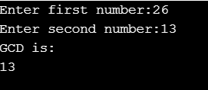

Link:

<http://103.53.53.18/mod/vpl/forms/submissionview.php?id=326&userid=1706>

Output:

Thus the Greatest Common Divisor (GCD) of two given numbers was calculated.